LiveConnect and Asset Hub: More transparency via sensor data
SICK‘s new digital solutions for the secure and flexible administration of digital twins

Waldkirch, 9 June 2020 – In order to access the virtual representation of the sensor and its data, SICK uses LiveConnect to deliver a standardized connection from an edge gateway to SICK Asset Hub. This visualizes the sensor status, thereby providing a foundation that opens up new opportunities for optimizing plant availability and process efficiency.

“Today, customers come to us with problems which have nothing to do with traditional automation engineering involving sensor systems, logic and actuators,” explains Christoph Müller, Senior Vice President Product Management at SICK AG. “Instead, they want to make business processes much more efficient. Sensors gather data that can help solve this problem,” says Müller.

SICK LiveConnect – the connection into the cloud
Industry 4.0 thrives on the generation and linking of data. LiveConnect from SICK provides a data connection to the sensor for web services and Industry 4.0 applications thereby making new business applications possible, for example the monitoring of ship emissions as evidence of adherence to legal requirements.
In order to access the virtual representation of the sensor and its data, SICK uses LiveConnect to deliver a standardized – and especially secure – connection from an edge gateway, like the SIM1012, to SICK Asset Hub or other SICK or third party applications. The LiveConnect web service connects the hardware, a SensorApp, and a cloud instance. This creates a connection between the sensor-oriented shop floor (SICK AppSpace) and the SICK IntegrationSpace cloud environment.
SICK Asset Hub – Making added value visible
The Asset Hub from SICK is a digital, web-based enterprise asset management (EAM) system. Thanks to the functionally rich and interactive view the Asset Hub provides of the individual sensors and machines as well as the plant as a whole, it creates more transparency in the value adding chain. This new transparency via virtual images, the digital twins, and assets – along their entire life cycles – enables greater plant availability and process efficiency. Data are evaluated in the Asset Hub to deliver valuable information about required inventories, maintenance, the right time for software updates, or the availability of devices. For example, the SICK Asset Hub service module offers services for maintenance employees and enables them to access sensor maintenance schedules and certificates, among other things.

The Asset Hub provides a flexible foundation for further asset-focused digital value adding services from SICK, for example the SICK Installed Base Manager, SICK LiveConnect, SICK Monitoring Box, or SICK Service Module.
SICK IntegrationSpace – all digital solutions on a single platform
Asset Hub and LiveConnect are components of the SICK IntegrationSpace. The SICK IntegrationSpace provides all the basic services and features required to offer digital services.
For more information, visit https://integrationspace.sick.com

Images: 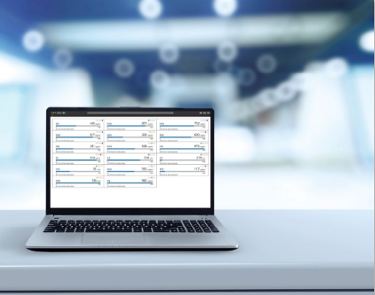
Image caption: One platform for all data: The Asset Hub and LiveConnect from SICK create transparency in real-time for sensor data

Contact
Melanie Jendro │PR manager │melanie.jendro@sick.de
+49 7681 202 4183 │+49 151 741 035 31

SICK is one of the world’s leading solutions providers for sensor-based applications in the industrial sector. Founded in 1946 by Dr.-Ing. e. h. Erwin Sick, the company with headquarters in Waldkirch im Breisgau near Freiburg ranks among the technological market leaders. With more than 50 subsidiaries and equity investments as well as numerous agencies, SICK maintains a presence around the globe. In the 2019 fiscal year, SICK had more than 10,000 employees worldwide and a group revenue of around EUR 1.8 billion. Additional information about SICK is available on the Internet at http://www.sick.com or by phone on +49 (0)7681202-4183

