The Power of SICK Nova now extends to 3D applications

Waldkirch, July 2024 – With the new Nova support for Ruler3000, SICK is now making fast, precise high-end 3D vision applications available to experts and non-experts alike. Within minutes, users can deploy custom applications, inspecting minute details at remarkable speeds. This advancement promises significant enhancements in production efficiency and yield.

With Nova now supporting Ruler3000, the speed, accuracy, and possible range of applications of SICK Nova have taken another large step forward. SICK Nova software, working together with the SIM2x00 and the Ruler3000 camera, now brings its well-established and highly valued user-friendly web interface to high-speed 3D applications. Thanks to the power of AI, this user-friendly setup enables even those companies lacking programming expertise to swiftly configure and manage complex applications.

SICK Nova opens up configurable 2D and 3D machine vision solutions to both professionals and novices

Well-known across a wide variety of industries, SICK Nova is the foundation software for configurable machine vision solutions and quality control applications. The software already offers a large selection of tools, making it a highly versatile software. What makes it truly stand out is the combination of AI functionality and a straightforward user interface. With these aspects, even users with no programming experience can quickly develop solutions for their company’s specific applications.

Ruler3000, the perfect vision partner

Powered by SICK’s highly sensitive CMOS sensor and innovative rapid on-chip calculation (ROCC) technology, the Ruler3000’s integrated streaming camera delivers reliable scans at rapid production speeds. Processing up to 15.4Gbit/s, it can generate up to 7000 full-frame 3D profiles per second. This allows it to accurately capture the true 3D shape of objects regardless of color or contrast. Additionally, it simultaneously captures greyscale and scattered light measurements, which results in more precise image processing and measurement.

The Ruler3000 is ideal across many industries and applications. Its high light sensitivity enables accurate inspection of even very dark or highly reflective materials. Meanwhile, its high dynamic range (HDR) function allows components with widely differing light remissions, such as tires and shiny metal assemblies, to be captured successfully in a single scan.

SIM2x00 Nova Sensor Integration Machine, the ideal interface

Designed for high-framerate and high-resolution machine vision tasks, the SIM2x00 Sensor Integration Machine is the connector between SICK Nova software and any one of a wide range of 2D and 3D streaming cameras. The specificity of its design allows it to process all the relevant data quickly and efficiently.

A wealth of possibilities

The quality and flexibility of Nova for Ruler3000 make it the ideal system for a surprising range of applications. This includes such things as the quality control of baked goods and confectionary where properties such as shape and dimensions can be checked at high speed, ensuring their quality even if there is no color contrast. The system is equally good for much smaller, more precise tasks such as checking the position the metal contacts around a semiconductor chip during electronic device assembly or the quality of welded joints.
Highly accurate 3D inspection enhances quality and accelerates processes across industries. The Nova for Ruler3000, joins SICK’s suite of products to address these needs and drive down production costs.

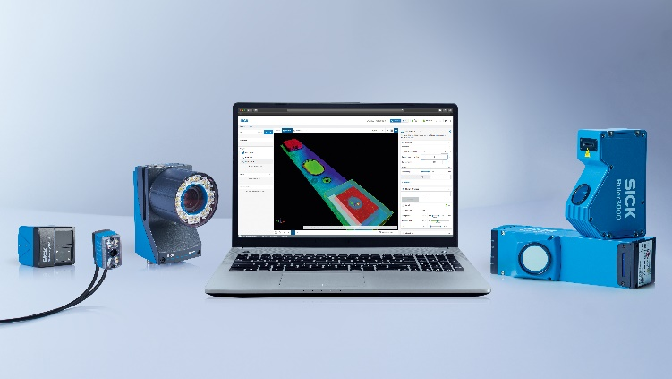

© SICK

SICK Nova software, working together with the SIM2x00 and the Ruler3000 camera, now brings its well-established and highly valued user-friendly web interface to high-speed 3D applications.

Contact person:
Heike Malinowski │Public Relations Specialist │heike.malinowski@sick.de
+49 211 5301-146 │+49 160 5281 303
SICK is one of the world’s leading solutions providers for sensor-based applications in the industrial sector. Founded in 1946 by Dr.-Ing. e. h. Erwin Sick, the company with headquarters in Waldkirch im Breisgau near Freiburg ranks among the technological market leaders. With 60 subsidiaries and equity investments as well as numerous agencies, SICK maintains a presence around the globe. SICK has more than 12,000 employees worldwide and generated a group revenue of EUR 2.3 billion in the 2023 fiscal year. Additional information about SICK is available at www.sick.com

