FTMg flow sensor: portfolio and capabilities expanded
Multi-function sensor from SICK: new nominal diameters for ring circuits and cloud integration for continuous compressed air monitoring
Waldkirch, August 31, 2022 – SICK has expanded the capabilities of the FTMg flow measurement device for continuous and intelligent monitoring of compressed air networks and connected consumers. The multi-function sensor for up to eight process parameters is now available with new nominal diameters of DN40 and DN50 for mechanical integration into ring circuits and superordinate compressed air networks. Furthermore, with the help of the FTMg Monitoring App from SICK, its measurement data can be used in an intelligent complete solution for cost-effective and continuous compressed air monitoring.
The FTMg (Flow Thermal Meter for gases) flow sensor measures the flow velocity, volume flow, total volume, mass flow, total mass, energy, and the current pressure and temperature of the compressed air in pneumatic networks. With the nominal diameters DN15, DN20 and DN25, it has been possible to set up measurement points on or close to compressed air consuming machines. With the new nominal diameters DN40 and DN50, it is now also possible to integrate the multi-function sensor into compressed air ring circuits. This means that the entire compressed air network can be continuously monitoring using a sensor family that is characterized by its high measurement dynamics and which can be operated with almost no pressure losses.
Intelligent energy monitoring especially for small and medium compressed air networks
The Monitoring Box from SICK is a cloud-based platform for condition and process monitoring of sensors, actuators, machines and plants – and is now available as a turn-key solution for compressed air monitoring of, in particular small and medium compressed air infrastructures. It collects and visualizes, via the FTMg app, live and historical compressed air consumption data as well as correlated pressure and temperature values. Thanks to this transparency, the Monitoring Box offers numerous advantages to operators of CNC machines, ultrasound welding systems, injection molding machines, assembly cells, and other compressed air consuming machines and equipment. Via a clear and intuitive to use dashboard, cost drivers in the network can be identified, increased consumptions detected and output as alerts, and work recommendations for optimizing maintenance processes and minimizing downtimes generated. The purpose of monitoring the compressed air consumption is therefore to ensure, via an efficient machine operation and the use of trouble-free pneumatic components, a cost-efficient and sustainable usage of this energy form.
Monitoring Box and FTMg: entry-level in-house energy management system
The complete solution comprising the Monitoring Box and an arbitrary number of FTMg devices in the compressed air network is especially interesting for customers who do not yet have an energy management system. The acquisition and analysis of compressed air data helps them to derive measures for reducing the energy consumption in their pneumatic networks, e.g., savings through switch-on and switch-off management, compressor regulation, or peak load management. Furthermore, operators can strive for certification according to DIN EN50001, which is a prerequisite in Germany for partial exemption from the EEG (Renewable Energy Act) levy as well as relief for manufacturing companies from the electricity and energy tax. In addition, the “Federal funding for energy efficiency in the economy” investment program funds, amongst other things, software and hardware for measurement and control technology as well as sensors associated with the establishment or use of an energy or environmental management system.

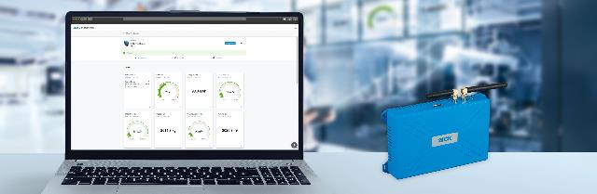 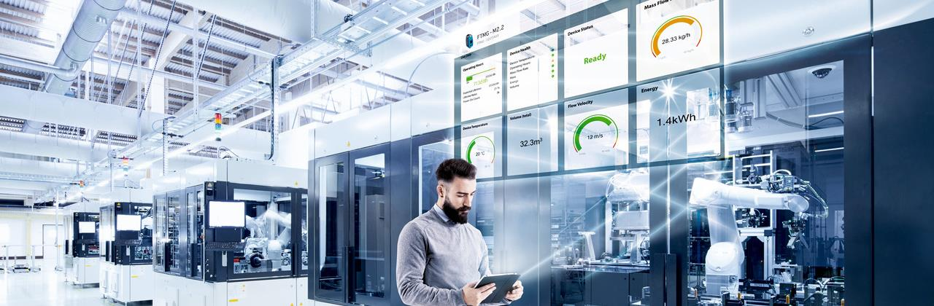
The Monitoring Box collects and visualizes live and historical compressed air consumption data as well as correlated pressure and temperature values.

Contact
Melanie Jendro │PR manager │melanie.jendro@sick.de
+49 7681 202 4183 │+49 151 741 035 31

SICK is one of the world’s leading solutions providers for sensor-based applications in the industrial sector. Founded in 1946 by Dr.-Ing. e. h. Erwin Sick, the company with headquarters in Waldkirch im Breisgau near Freiburg ranks among the technological market leaders. With more than 50 subsidiaries and equity investments as well as numerous agencies, SICK maintains a presence around the globe. In the 2021 fiscal year, SICK had more than 11,000 employees worldwide and a group revenue of around EUR 2 billion. Additional information about SICK is available on the Internet at http://www.sick.com or by phone on +49 (0)7681202-4183.

