MARITIME – Service Request Form

Customer Information:
Customer No. : |  | PO No. :
Company :
Contact :
Phone :
Email :

Vessel Information:
Vessel Name :
IMO No. :
Contact :
Phone :
Email :

Analyzer Information:
Analyzer | Measuring Points | Serial Number
 | [Qty.]
MCS100E MARSIC200 MARSIC300
MCS100E MARSIC200 MARSIC300
MCS100E MARSIC200 MARSIC300
MCS100E MARSIC200 MARSIC300

Service Request:
Installation Preventive Maintenance Service Other

Problem Description:

IMPORTANT: Please provide the following information best possible to accelerate your request!

For MARSIC300 only, please select your air conditioning unit:
Option 1 | Option 2 | Option 3 | Option 4
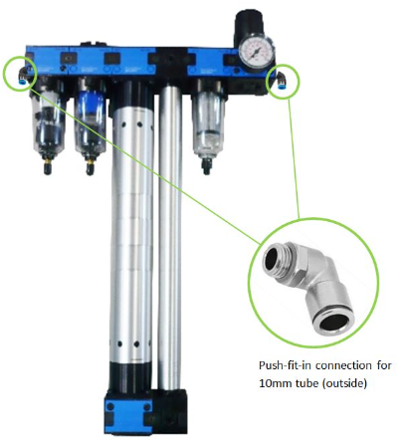 | 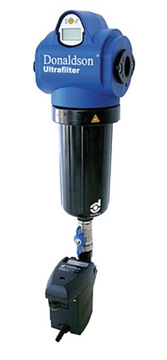 | 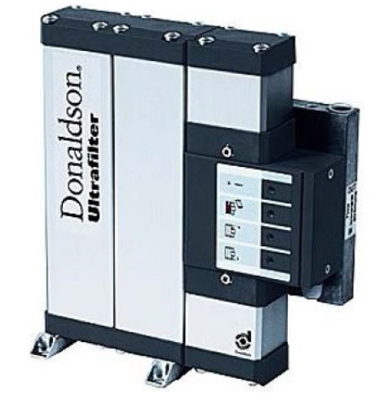 | 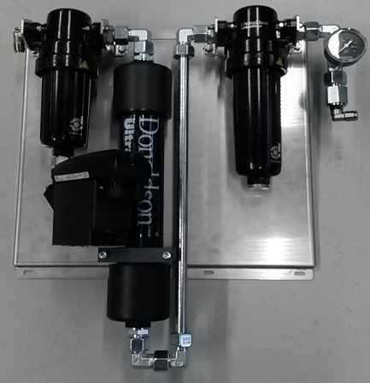

For MCS100E only, please attach photo/screenshot of analyzer panel:
MCS100E: Analyzer Panel screenshot attached

Vessel Schedule:
Please provide next five ports.
Port / City | Arrival  Date / Time | Departure  Date / Time

Available Spare Parts on Board:
Description | Quantity | SICK-Part no.

Available Test Gases on Board:
Gas mixture - component(s) and concentration(s) | Bottle size | Filling level (pressure) | Pressure reducer available | Connector Type | Expiration Date

Analyzer Configuration Information:
(For instructions please see below)
SOPAS File Logbook File

Instructions on how to save the analyzer configuration file

SOPAS ET: Preliminary steps

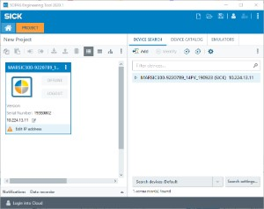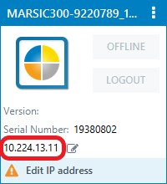
Description
Pictures, Screenshots
1
Start SOPAS ET on the computer.
2
Once SOPAS ET is running, click on "Search devices: Default".
3
Depending on the settings in SOPAS ET:
- The analyzer is either detected automatically,

or

- If not, please add the analyzer manually by double-clicking on the found “analyzer” line on the right in the project window.
4
NOTE: Do NOT change the IP address of the analyzer, as it is configured to communicate with the customers control room!

Please change the IP address in the “Windows” settings of the computer.

SOPAS ET: Set IP Address at computer

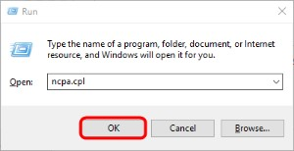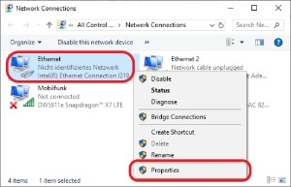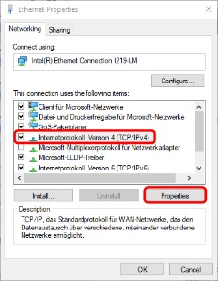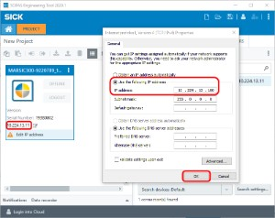
Description
Pictures, Screenshots
1
- Press the key combination “Windows-key + R” to open the “Run” window

- Enter: ncpa.cpl

- Click on <OK>
2
Open the Ethernet properties by right-clicking on the corresponding connection.
3
Select "Internetprotocol, Version 4(TCP/IPv4)" and click on "Properties".
4
Select "Use the following IP address:" and have a lookat the IP address of the analyzer and enter the IP address as follows:

- Use the same network identifier (e.g. 10.224.13.xxx)

- Use a different host identifier (e.g. xxx.xxx.xxx.100, whereas the number can be between 0 …255 – EXCEPT 11)
5
Close all open windows for the network settings.
Elevated privileges are required to change the network settings!

SOPAS ET: Establish connection to the analyzer

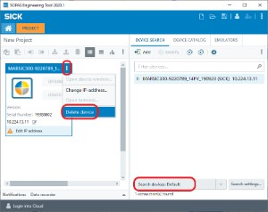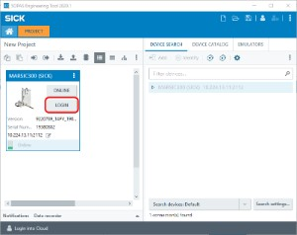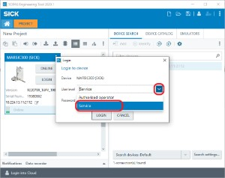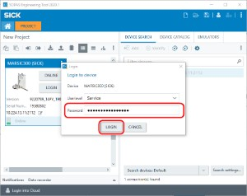
Description
Pictures, Screenshots
1
Return to the window SOPAS ET.

Delete the initially detected analyzer and start searching again for the analyzer.
2
After adding the analyzer into the project (either manually or automatically) select "Login".
3
Select "Service" from the drop-down menu.
4
Enter the password and confirm with "Login".

- For MARSIC300: MARSIC300SERVICE

- For MARSIC200: hidden

SOPAS ET: Save project and logbook files

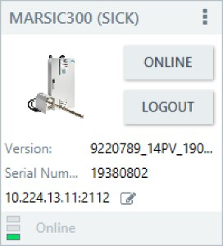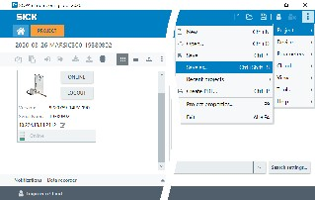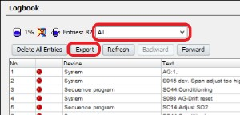
Description
Pictures, Screenshots
1
Connect to device and go online.
2

Save the project file:
- Click on the icon to open the menu

- Select Project then Save as…

- In the following window choose a path and file name and confirm with Save

3
Open the device page and save the logbook:
- Select: Diagnosis – Logbook

- Verify that “All” is selected
- Click on Export

- In the following window choose a path and file name and confirm with Save

