Dr. Robert Bauer

Chairman of the Board

Portfolio: Technology & Digitalization

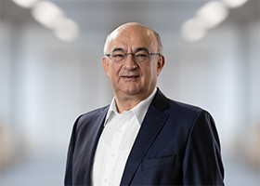
Dr. Bauer has been Chairman of the SICK AG Executive Board since October 1, 2006. He is also responsible for the Technology Division. He came to the company in 1994 as a division manager in the field of automation technology research and development before assuming overall responsibility for research and development in 1998. He was appointed to the Executive Board on January 1, 2000.
Born in Munich in 1960, Dr. Bauer studied electrical engineering with core modules on electrophysics/optics at the Technical University of Munich from 1979 to 1985. He received his doctorate in the field of semiconductor-based integrated optics in 1990.
SICK is one of the world’s leading solutions providers for sensor-based applications in the industrial sector. Founded in 1946 by Dr.-Ing. e. h. Erwin Sick, the company with headquarters in Waldkirch im Breisgau near Freiburg ranks among the technological market leaders. With more than 50 subsidiaries and equity investments as well as numerous agencies, SICK maintains a presence around the globe. In the 2020 fiscal year, SICK had more than 10,000 employees worldwide and a group revenue of around EUR 1.7 billion. Additional information about SICK is available on the Internet at http://www.sick.com

