VMS4200/5200 Volume Measurement Systems – when the actual size matters!

Outstanding measurement of dimensions for hitherto impossible throughput performance

Waldkirch, February 2019 – SICK will present the new VMS4200 Volume Measurement System and its MID- and NTEP-certified VMS5200 variant live at LogiMat 2019. This entirely redesigned method of dimensional measurement from SICK opens up completely new possibilities for the precise dimensioning and position determination of cuboid and irregularly shaped objects on stationary conveyor systems.

These system solutions are specified for transport speeds of up to 4 m/s. Highly dynamic and non-contact measurement provides hitherto impossible throughput rates for conveyor and sorting plants with high transport speeds. The considerably improved precision of height measurement now also enables the billable dimensioning of flat objects, such as books or letters with minimum heights of up to 20 mm.

No errors, greater throughput, quicker ROI

Inline measurement with millimeter accuracy enables greater throughputs in material flows and higher efficiency levels in storage logistics for operators of commercial and distribution centers, as well as courier, express, package and postal service providers. Costs and delays due to damaged or incorrect objects are prevented, and the handling of objects and freight is improved – increasing transport performance in distribution centers and hubs. The precise length, width and height information on the transported objects or freight enables optimum planning and use of storage and vehicle capacities. All this guarantees a rapid return on investment.

Approved for revenue recovery thanks to MID and NTEP
The VMS5200 is appropriately certified according to the European Measuring Instruments Directive 2014/32/EU (MID) and the American National Type Evaluation Program (NTEP). Further approvals, already in the pipeline, will permanently enhance the global use of the VMS5200. The retroactive billing of freight costs (revenue recovery) is thus virtually unlimited.
Millions of measurement values for millimeter-precise measurements
The VMS4200/5200 Volume Measurement System combines state-of-the-art measurement and evaluation technology in a single modular system structure. Two LMS4000 laser scanners detect the transported objects from two sides. The distance between the 2D LiDAR sensors can be varied in order to adapt the measurement field width to the object’s dimensions. It is therefore possible to measure object sizes of up to 5,500 mm x 1,600 mm x 1,100 mm, whereby the dimensional values achieve an accuracy of 5 mm x 5 mm x 2 mm. The ability to cover larger and smaller object dimensions increases object variance, and thus the flexibility and versatility of volume measurement. The LMS4000’s significantly improved laser performance and 6-fold increase in measurement resolution also lead to a major enhancement in the detection of dark objects. This improves plant availability, minimizes manual interventions, and results in corresponding sales growth in invoicing operations.
With a scanning frequency of 600 Hz, each LMS4000 produces more than half a million measurement points per second. In data terms, the object thus becomes an enormous, finely resolved cloud of measurement points, in which each individual point stands for one width and one height value. All measurement values are combined and calculated to form a 3D model of the object in the SIM2000 Sensor Integration Machine, the VMS4200/5200’s evaluation unit. The output of measurement values as a PCD file helps customers recognize damaged or deformed objects on the basis of the three-dimensional object image, preventing their storage. This increases efficiency in storage logistics and allows the tracing back of objects to the point of damage in the material handling process. The VMS4200/5200 permits early estimations of the necessary storage spaces and optimization of the loading of vehicles, containers, swap bodies or shelves. Downstream processes can thus be more efficiently controlled. Warehouse and freight costs are reduced, and potential claims for compensation prevented.
The first system with dynamic switching of the scale value
In view of the permissible measurement tolerances, the VMS420/5200 is one of the first systems worldwide to offer automatic dynamic switching of the scale value depending on the dimensions of the object. Thus, for example, smaller objects with a scale value of 5 mm x 5 mm x 2 mm and larger objects with a scale value of 10 mm x 5 mm x 5 mm can be dimensioned during inline measurement. This ensures increased dimensioning rates and, in the case of the VMS5200, permits use of the measurement results for invoicing purposes.
Smart modularity minimizes installation and adjustment costs
The modular system concept of the VMS4200/5200 offers a range of advantages. Guided by easy-to-use thinking, very short installation times can be achieved in the most varied of environments thanks to the LMS4000 scanner holder that offers very simple mounting and flexibly adaptable widths in all situations. The modular and simple construction makes a lasting contribution towards reducing installation costs. Extremely short setup times are possible using the completely new VMS Installation Wizard integrated in the SOPAS engineering tool. The interactive touchscreen display of the legal-for-trade VMS5200 visualizes all relevant measurement values, as well as system and diagnostic information. Together with the software logbook function, this can be issued for market surveillance purposes without requiring a PC.
Cleverer software split for greater flexibility and lower maintenance costs
The SIM2000 has numerous external interfaces and selectable Ethernet-based fieldbuses. This allows the easy adaptation of multi-dimensional object measurement to meet the individual requirements of the plant operator. The software is also modularized: The measurement software and application-specific system programming are separated from one another. This increases flexibility when correcting errors, and leads to cost savings through shorter service deployment times. It is also possible to implement customer-specific modifications and system optimizations during operation.
In the case of the VMS5200, separation of the software areas also reduces system maintenance costs because less effort is required for calibration support. In addition, no renewed certification of the entire system is required if there is a change in the user software. Customer-specific expansions can thus be implemented easily and efficiently. The VMS4200/5200 can be operated as a stand-alone system, in combination with reading and identification systems, or with additional weighing technology.

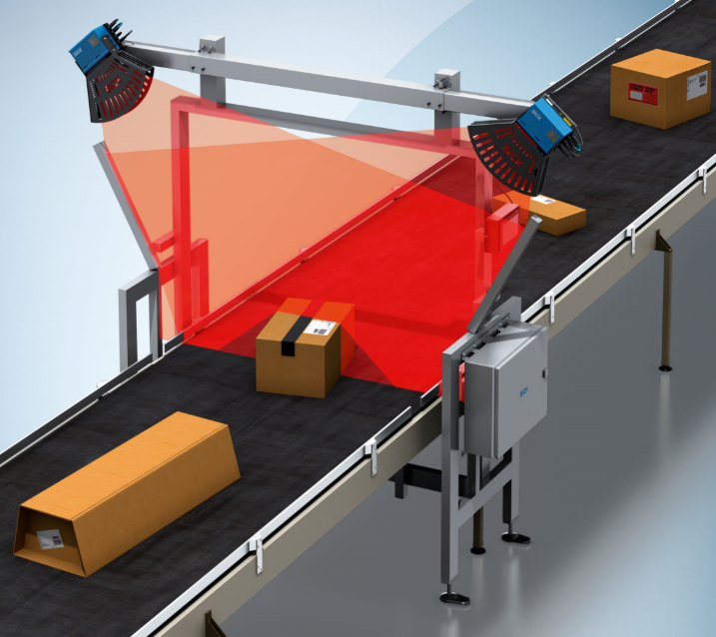
The VMS4200/5200 Volume Measurement System is used for the dynamic measurement and position detection of cuboid and irregularly shaped objects on stationary conveyor systems.
SICK is one of the world’s leading producers of sensors and sensor solutions for industrial applications. The company, founded in 1946 by Dr. Erwin Sick and based in Waldkirch-im-Breisgau near Freiburg, is a technology and market leader with a global presence – with more than 50 subsidiaries and associated companies, as well as numerous sales offices. SICK achieved Group sales of about EUR 1.5 bn. in the 2017 fiscal year with almost 9,000 employees worldwide.
Further information on SICK is available at http://www.sick.com.

Press contact:
Ms Melanie Jendro, Public Relations, SICK AG, Waldkirch
Tel.: +49 (0)7681 202-4183
e-mail: melanie.jendro@sick.de

This is surely not such a major difference, or is it? After all, the article talked about “sizes of up to 5,500 mm x 1,600 mm x 1,100 mm” – which is very different.

